Continuous Data Ingestion using Snowpipe (GCS + Pub/Sub)
Objective
Build a pipeline:
GCS Bucket → Pub/Sub Notification → Snowpipe → Snowflake Table
Data will load automatically when files arrive.

1. Architecture Overview
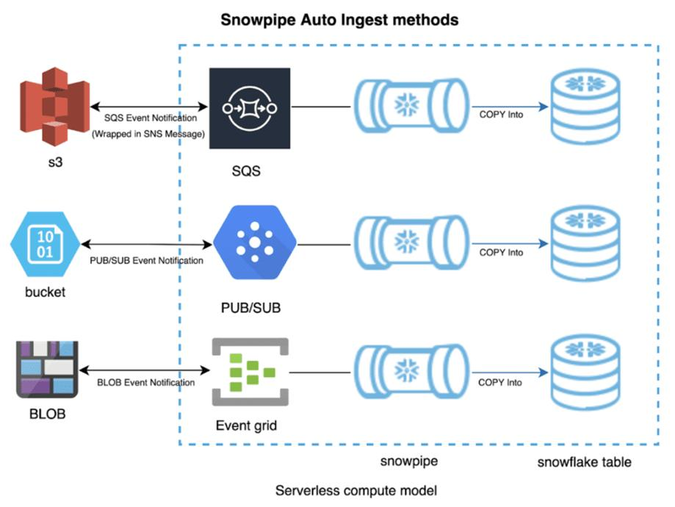
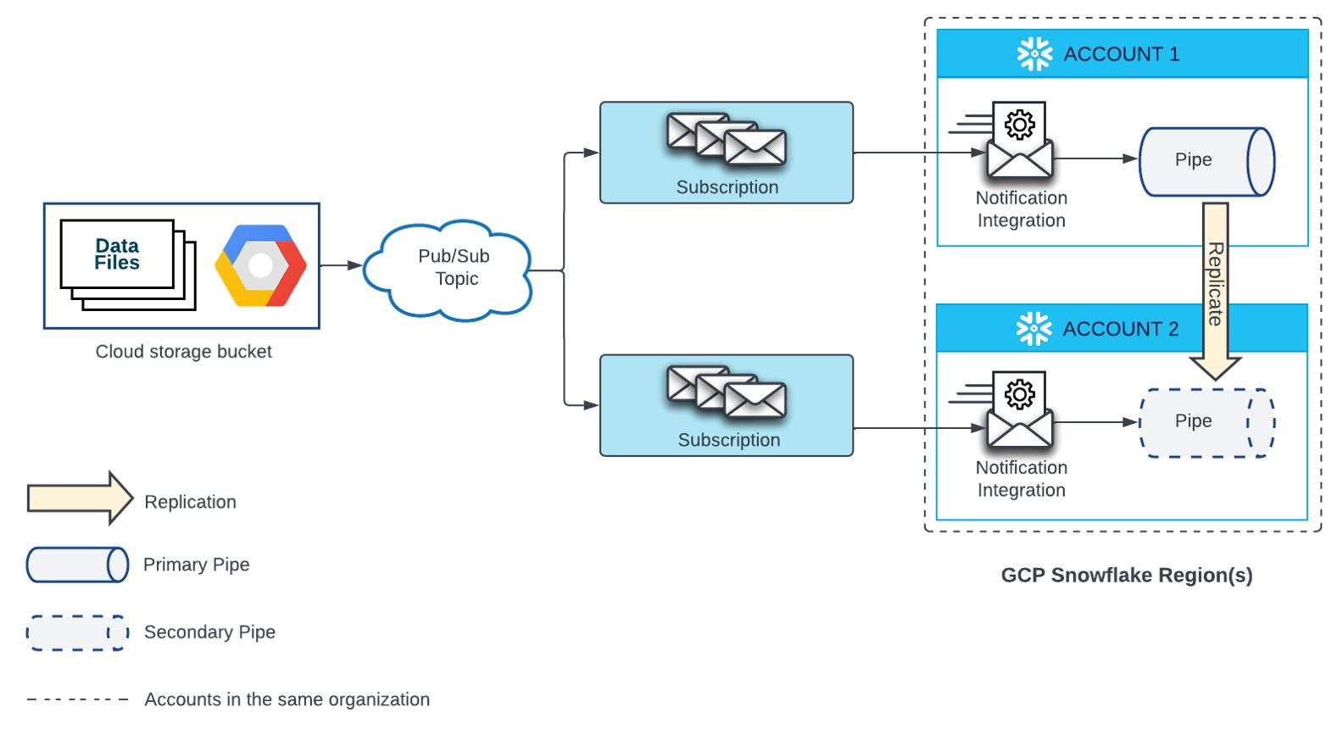
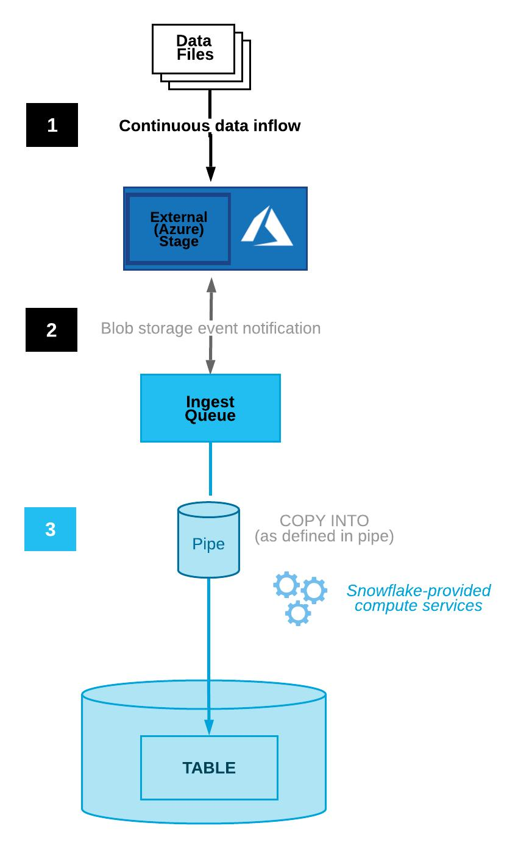

2. Prerequisites
Snowflake
- Account in Snowflake
- Role: ACCOUNTADMIN
- Warehouse created
GCP
- Project in Google Cloud
- GCS bucket
- Pub/Sub enabled

3. Step 1 — Create GCS Bucket
gsutil mb -l us-central1 gs://snowpipe-demo-bucket
Upload a sample file:
gsutil cp data.csv gs://snowpipe-demo-bucket/
Sample data.csv:
1,Vikash,1000
2,Rahul,2000
3,Amit,1500

4. Step 2 — Create Pub/Sub Topic
gcloud pubsub topics create snowpipe-topic
Create subscription:
gcloud pubsub subscriptions create snowpipe-sub --topic=snowpipe-topic

5. Step 3 — Enable GCS Notifications
gsutil notification create \
-t snowpipe-topic \
-f json \
-e OBJECT_FINALIZE \
gs://snowpipe-demo-bucket
Now:
✔ Every new file → Pub/Sub message triggered

6. Step 4 — Snowflake Setup
6.1 Create Table
CREATE OR REPLACE TABLE sales_raw (
id INT,
name STRING,
amount FLOAT
);

6.2 Create File Format
CREATE OR REPLACE FILE FORMAT csv_format
TYPE = 'CSV'
FIELD_OPTIONALLY_ENCLOSED_BY = '"'
SKIP_HEADER = 0;

6.3 Create Storage Integration
CREATE OR REPLACE STORAGE INTEGRATION gcs_int
TYPE = EXTERNAL_STAGE
STORAGE_PROVIDER = GCS
ENABLED = TRUE
STORAGE_ALLOWED_LOCATIONS = ('gcs://snowpipe-demo-bucket/');

6.4 Get Service Account
DESC INTEGRATION gcs_int;
Copy:
STORAGE_GCP_SERVICE_ACCOUNT

7. Step 5 — Grant GCS Access
Go to GCP:
- IAM → Add member
- Paste service account from Snowflake
- Role: Storage Object Viewer

8. Step 6 — Create External Stage
CREATE OR REPLACE STAGE gcs_stage
URL='gcs://snowpipe-demo-bucket/'
STORAGE_INTEGRATION = gcs_int
FILE_FORMAT = csv_format;

9. Step 7 — Create Snowpipe (Core Step)
CREATE OR REPLACE PIPE sales_pipe
AUTO_INGEST = TRUE
AS
COPY INTO sales_raw
FROM @gcs_stage;

Get Notification Channel
SHOW PIPES;
Copy:
notification_channel

10. Step 8 — Link Pub/Sub to Snowpipe
gcloud pubsub subscriptions update snowpipe-sub \
--push-endpoint=<notification_channel>

11. Step 9 — Test the Pipeline
Upload a new file:
gsutil cp new_data.csv gs://snowpipe-demo-bucket/
Wait a few seconds…
Check data:
SELECT * FROM sales_raw;
✔ Data appears automatically → SUCCESS

12. Monitor Snowpipe
SELECT * FROM TABLE(INFORMATION_SCHEMA.PIPE_USAGE_HISTORY());
Check load history:
SELECT * FROM INFORMATION_SCHEMA.LOAD_HISTORY;

13. Error Handling
View errors
SELECT *
FROM TABLE(VALIDATE(sales_raw, JOB_ID => '_last'));
Skip bad records
COPY INTO sales_raw
FROM @gcs_stage
ON_ERROR = 'CONTINUE';

14. Advanced Enhancements
14.1 Partitioned Loading
Store files like:
/data/2026/04/10/file.csv

14.2 JSON Ingestion
CREATE TABLE raw_json (data VARIANT);
COPY INTO raw_json FROM @gcs_stage FILE_FORMAT = (TYPE = JSON);

14.3 Stream + Task (Automation)
CREATE STREAM sales_stream ON TABLE sales_raw;
CREATE TASK transform_task
WAREHOUSE = compute_wh
SCHEDULE = '1 MINUTE'
AS
INSERT INTO sales_final
SELECT * FROM sales_stream;

15. Real-World Production Architecture
App / API
↓
GCS Bucket
↓
Pub/Sub
↓
Snowpipe
↓
Raw Table
↓
Streams + Tasks
↓
Curated Tables
↓
BI / ML

16. Azure Equivalent
GCP | Azure
GCS | Blob Storage
Pub/Sub | Event Grid
Notification | Event Subscription

